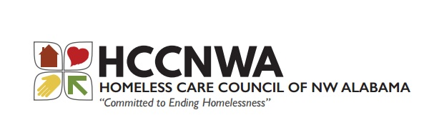
Florence, Alabama 35630 hccnwal@gmail.com
www.homelesscarecouncil.com

2023 Regular HUD Continuum of Care NOFO Ranking

Good afternoon,

As part of our ongoing commitment to transparency and to comply with HUD requirements and regulations, the rating and ranking of projects is below.

No projects were rejected or reallocated from this competition.

Community Action 2023 HMIS $16,659 Ranked 1
Community Action 2023 PH & RRH Chance Project $395,955 Ranked 2
Community Action 2023 HMIS Bonus $22,000 Ranked 3
Homeless Care Council Planning Project Not ranked

The HUD NOFO Grant is due Thursday, September 28, 2023.

